CSA13 – CLOUD COMPUTING AND BIG DATA ANALYTICS

LAB RECORD – LIST OF EXPERIMENTS
Note: Ex.No. 2 shows the actual Zoho Creator application built by the student. All other output screens are illustrative mockups styled to match the Zoho Creator interface, generated for reference purposes.

Ex. No: 1 Flight Reservation System

Aim
To create a simple cloud software application for Flight Reservation System using Zoho Creator to demonstrate the Software as a Service (SaaS) cloud model. The application includes fields such as One Way, Round Trip, From, To, Departure Date, Travelers & Class, Fare Type, and International and Domestic Flights.

Output
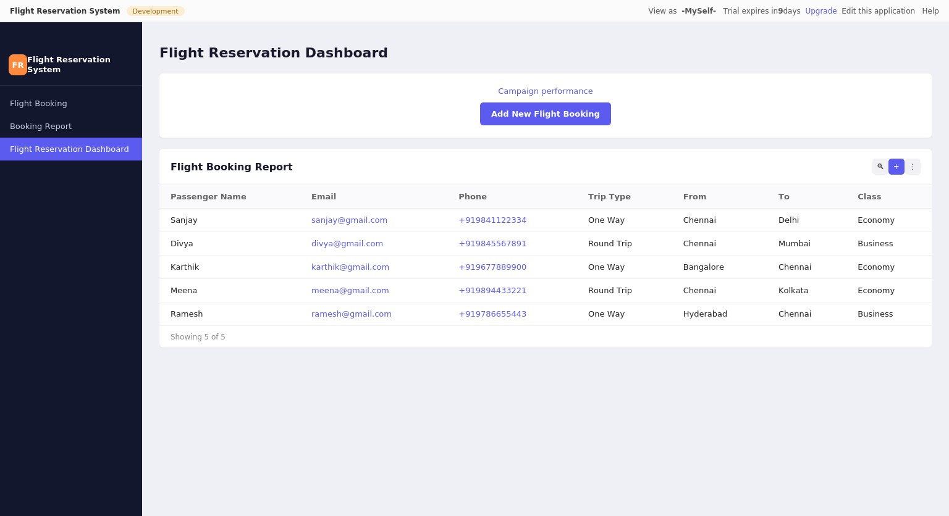
Flight Reservation Dashboard
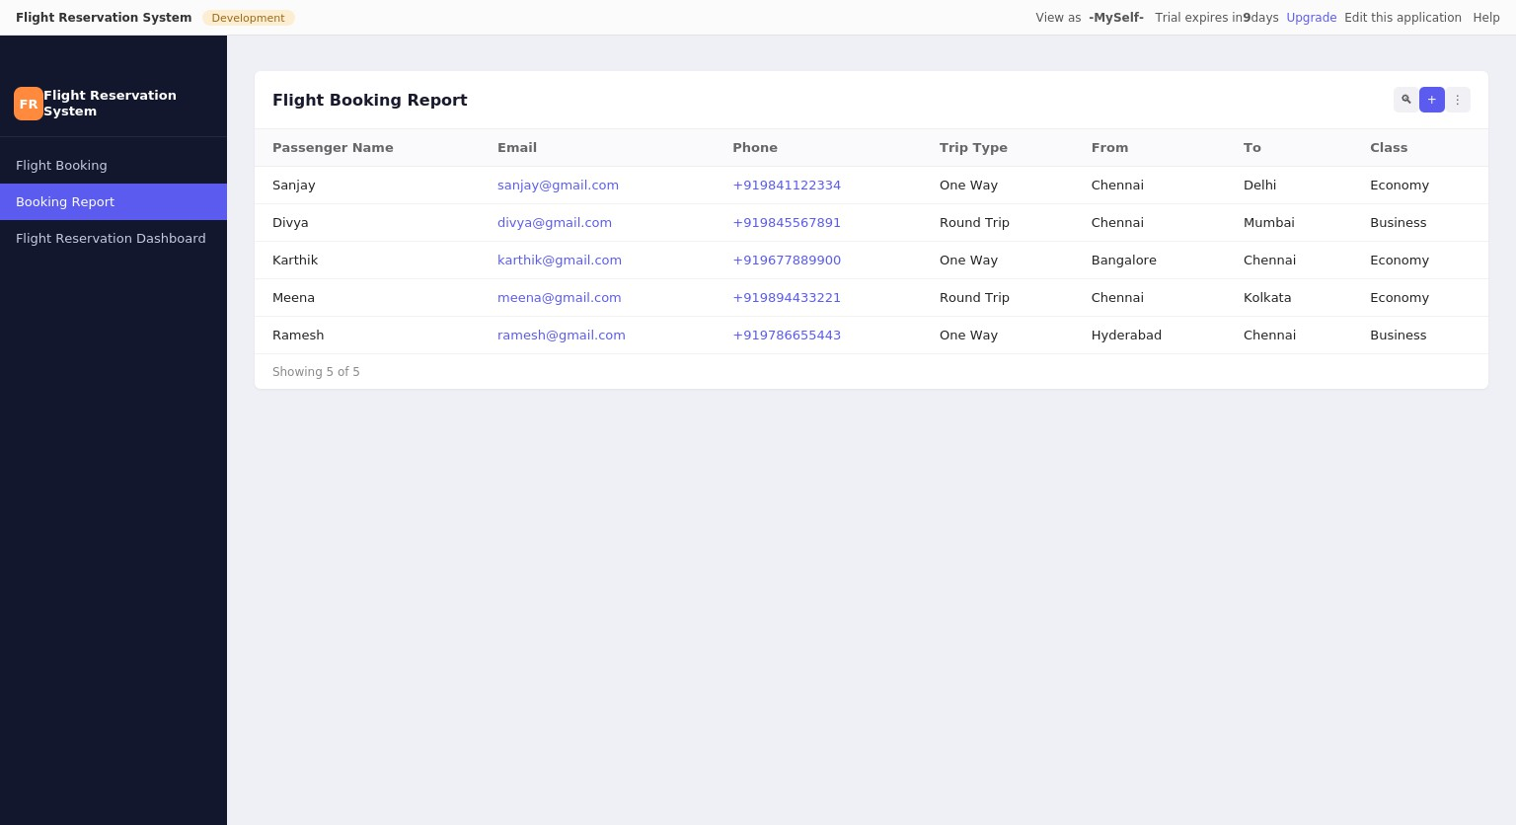

Flight Booking Report
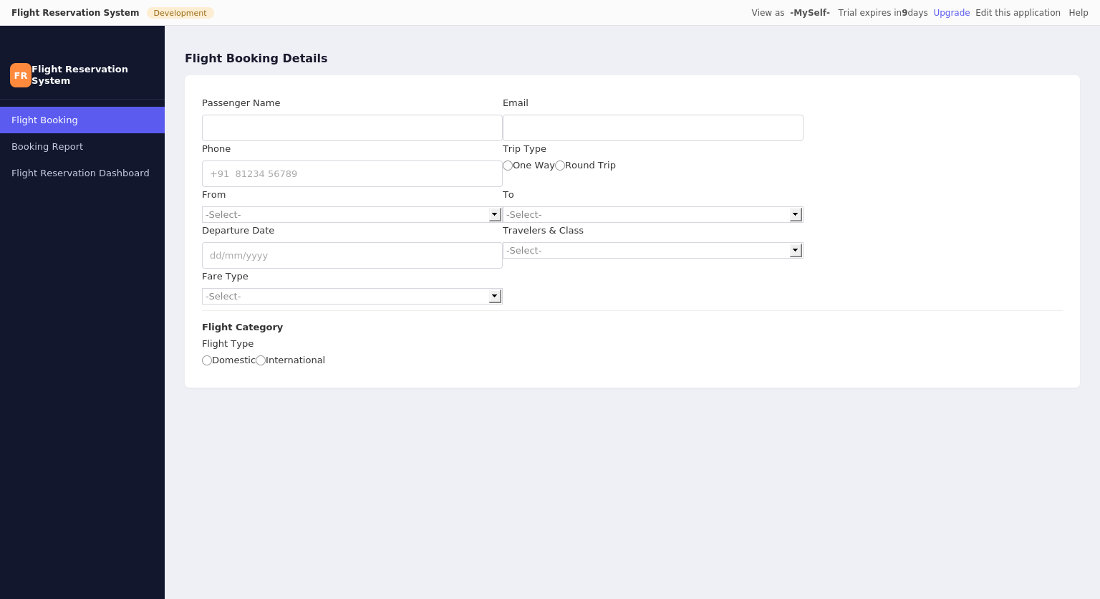
Flight Booking Details Form

Result
Thus the simple cloud software application for Flight Reservation System was created successfully using Zoho Creator to demonstrate the SaaS cloud model.

Ex. No: 2 Property Buying & Rental System (Chennai)

Aim
To create a simple Property Buying & Rental System using Zoho Creator to demonstrate the Software as a Service (SaaS) cloud model.

Output
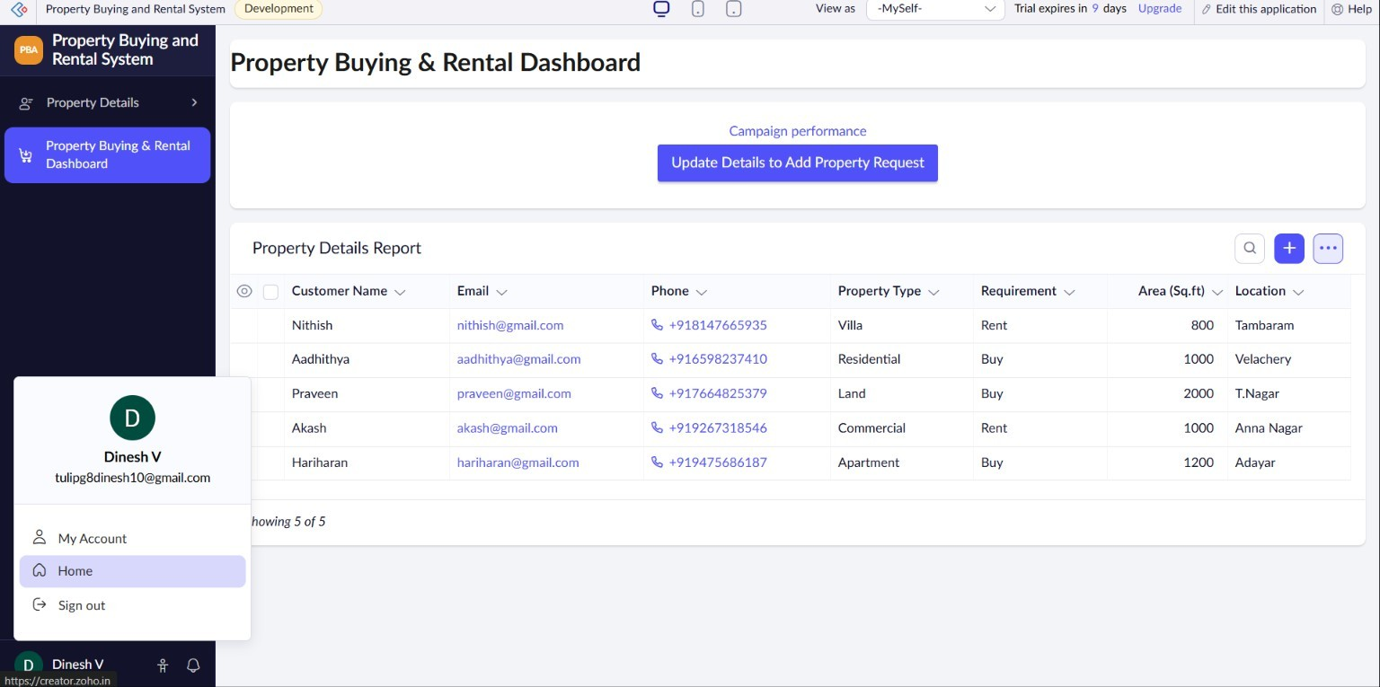
Property Buying & Rental Dashboard
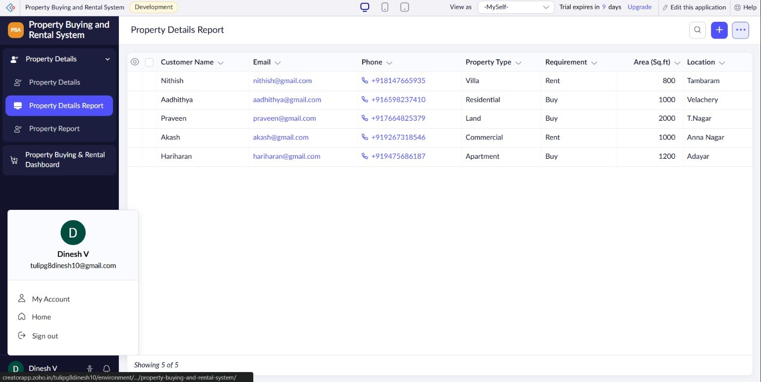
Property Details Report

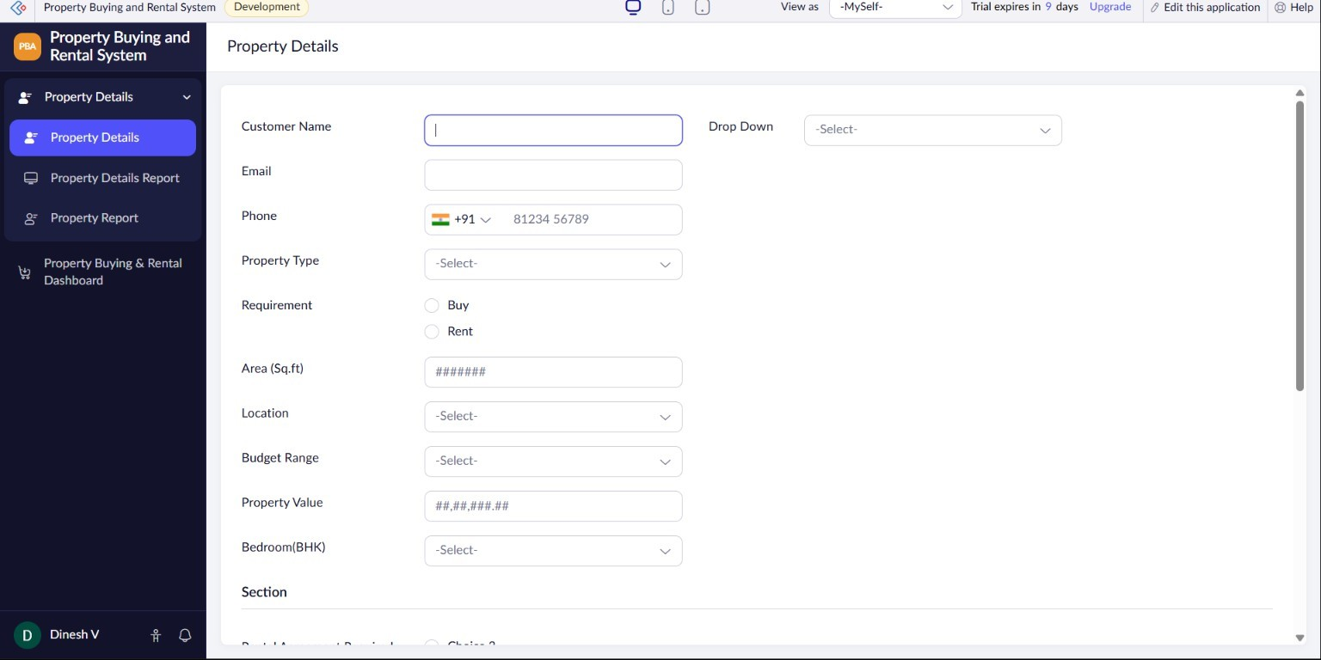
Property Details Entry Form

Result
Thus the simple cloud software application for Property Buying & Rental System (Chennai) was created successfully using Zoho Creator to demonstrate the SaaS cloud model.

Ex. No: 3 Car Booking Reservation System

Aim
To create a simple cloud software application for Car Booking Reservation System using Zoho Creator to demonstrate the Software as a Service (SaaS) cloud model. The application includes fields such as Search for Cabs, From, To, Rental, Out Station, Package Type, and Hours/Days.

Output
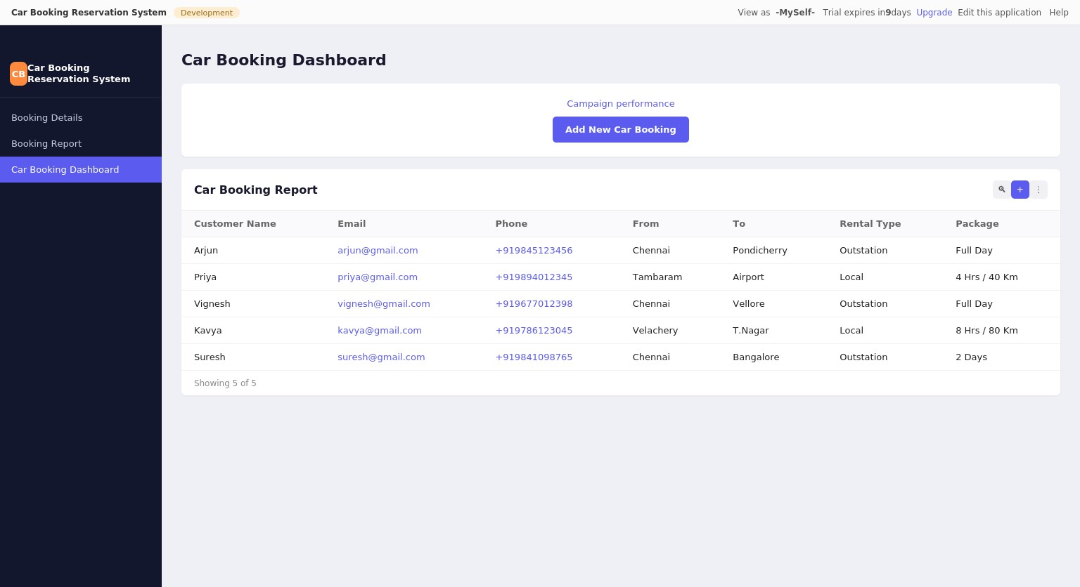
Car Booking Dashboard
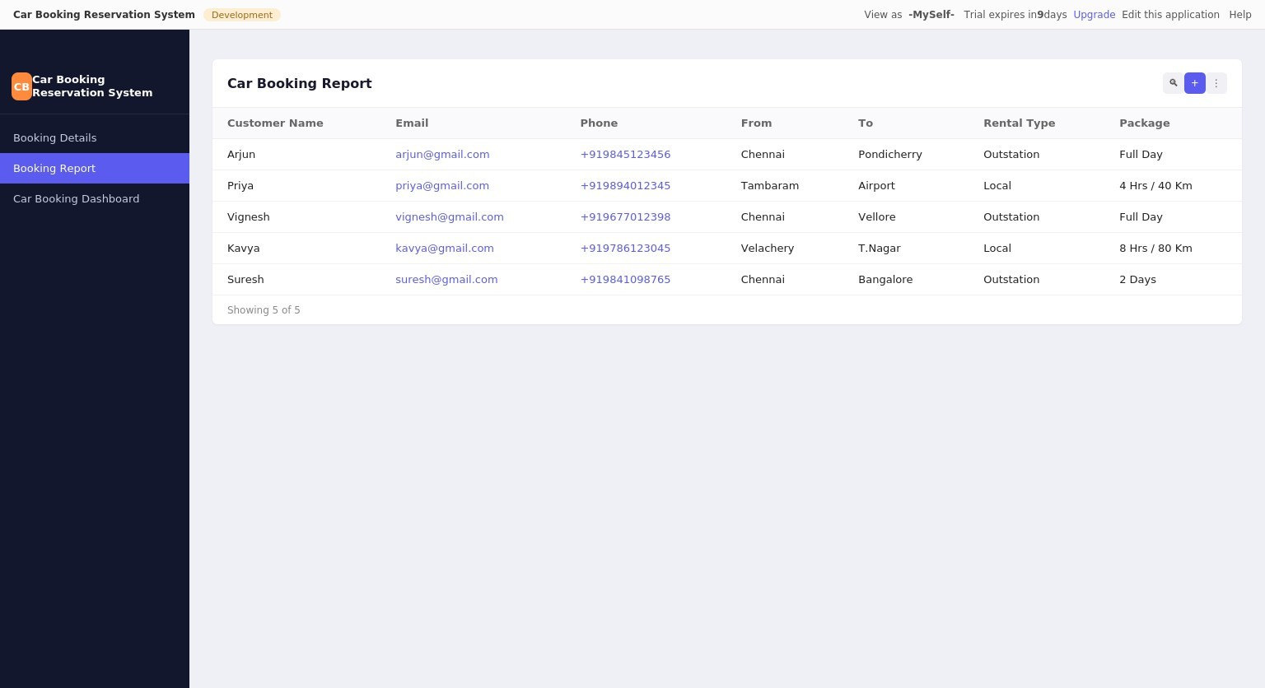
Car Booking Report

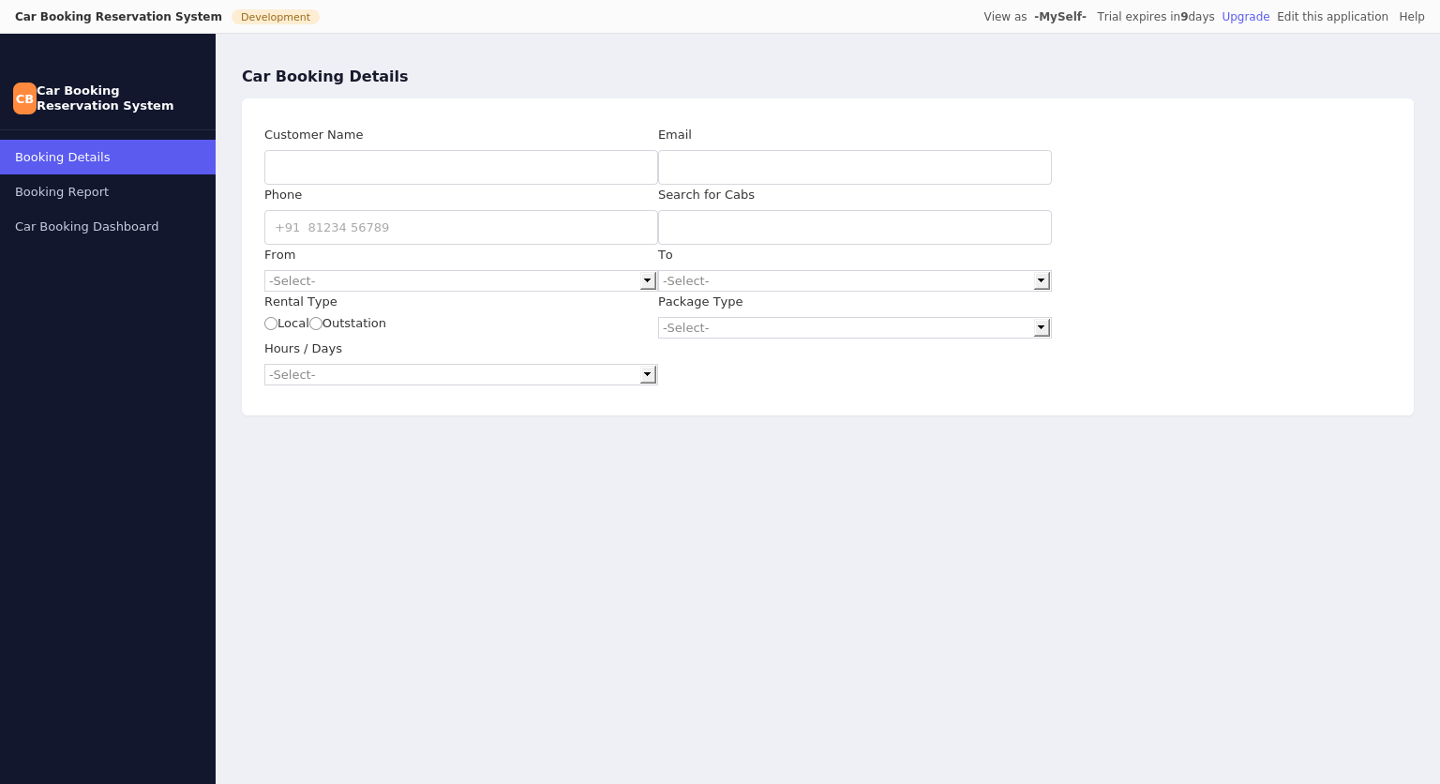
Car Booking Details Form

Result
Thus the simple cloud software application for Car Booking Reservation System was created successfully using Zoho Creator to demonstrate the SaaS cloud model.

Ex. No: 4 Library Book Reservation System (SIMATS Library)

Aim
To create a simple cloud software application for the Library Book Reservation System for SIMATS Library using Zoho Creator to demonstrate the Software as a Service (SaaS) cloud model. The application includes fields such as Title of the Book, Author, Publications, Year, Edition, No. of Copies, Rack No., and Status (Taken/Returned).

Output
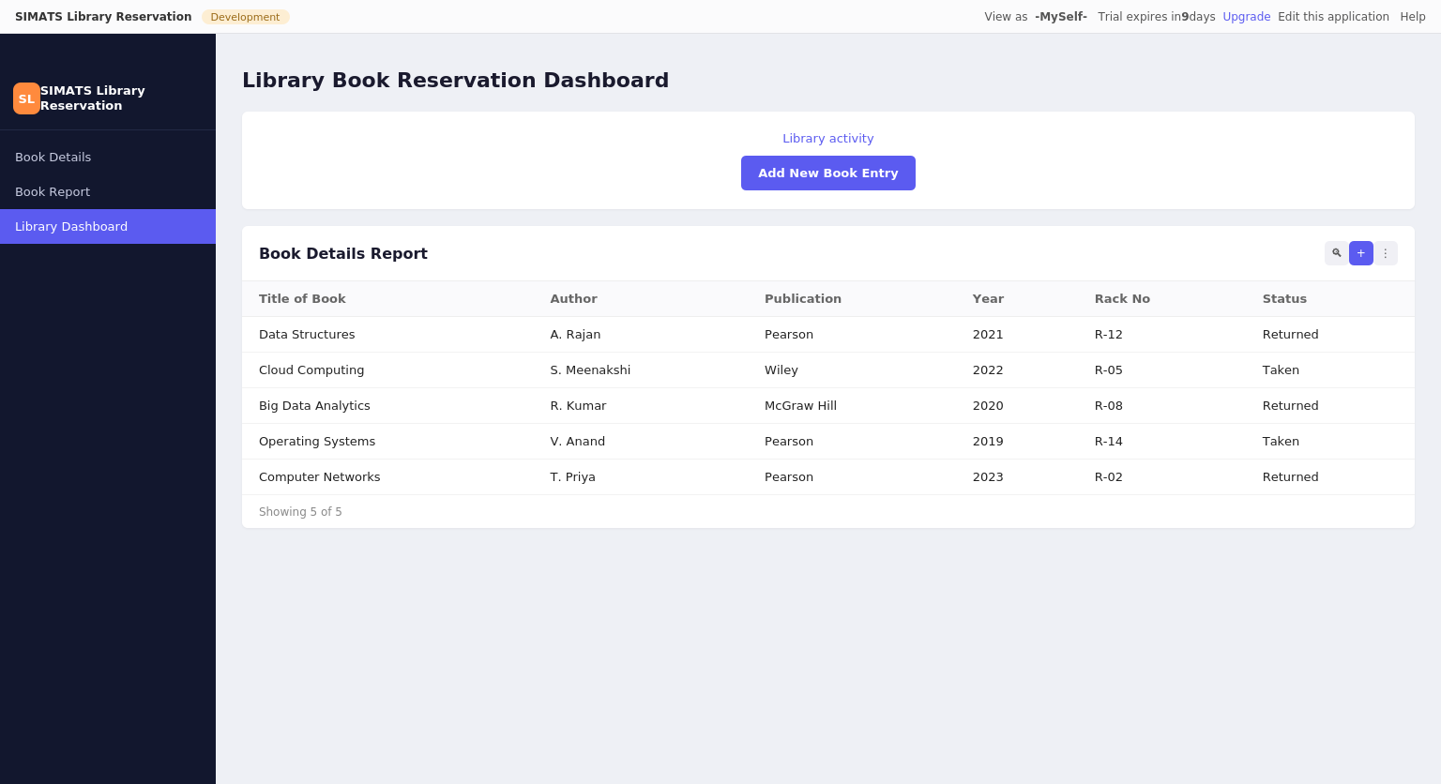
Library Book Reservation Dashboard
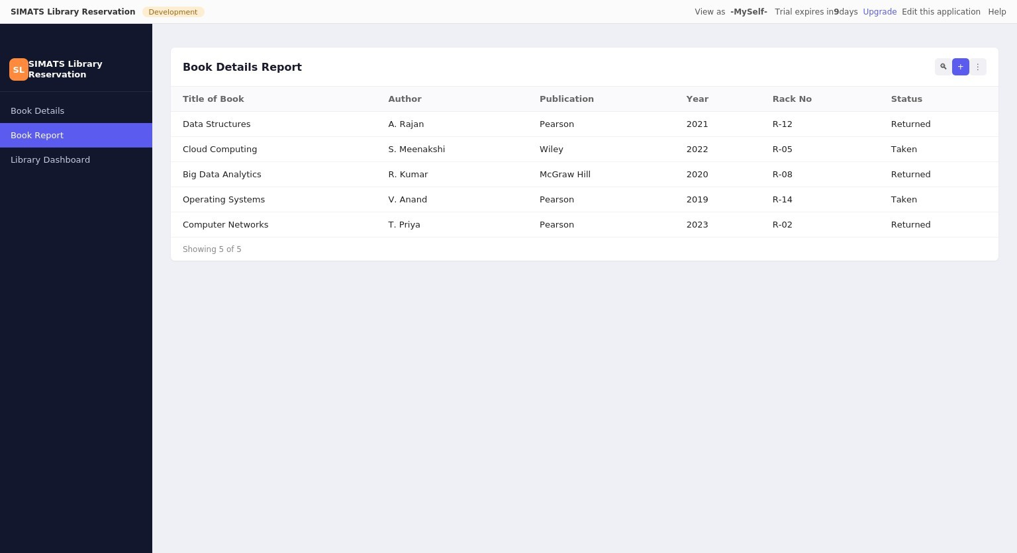
Book Details Report

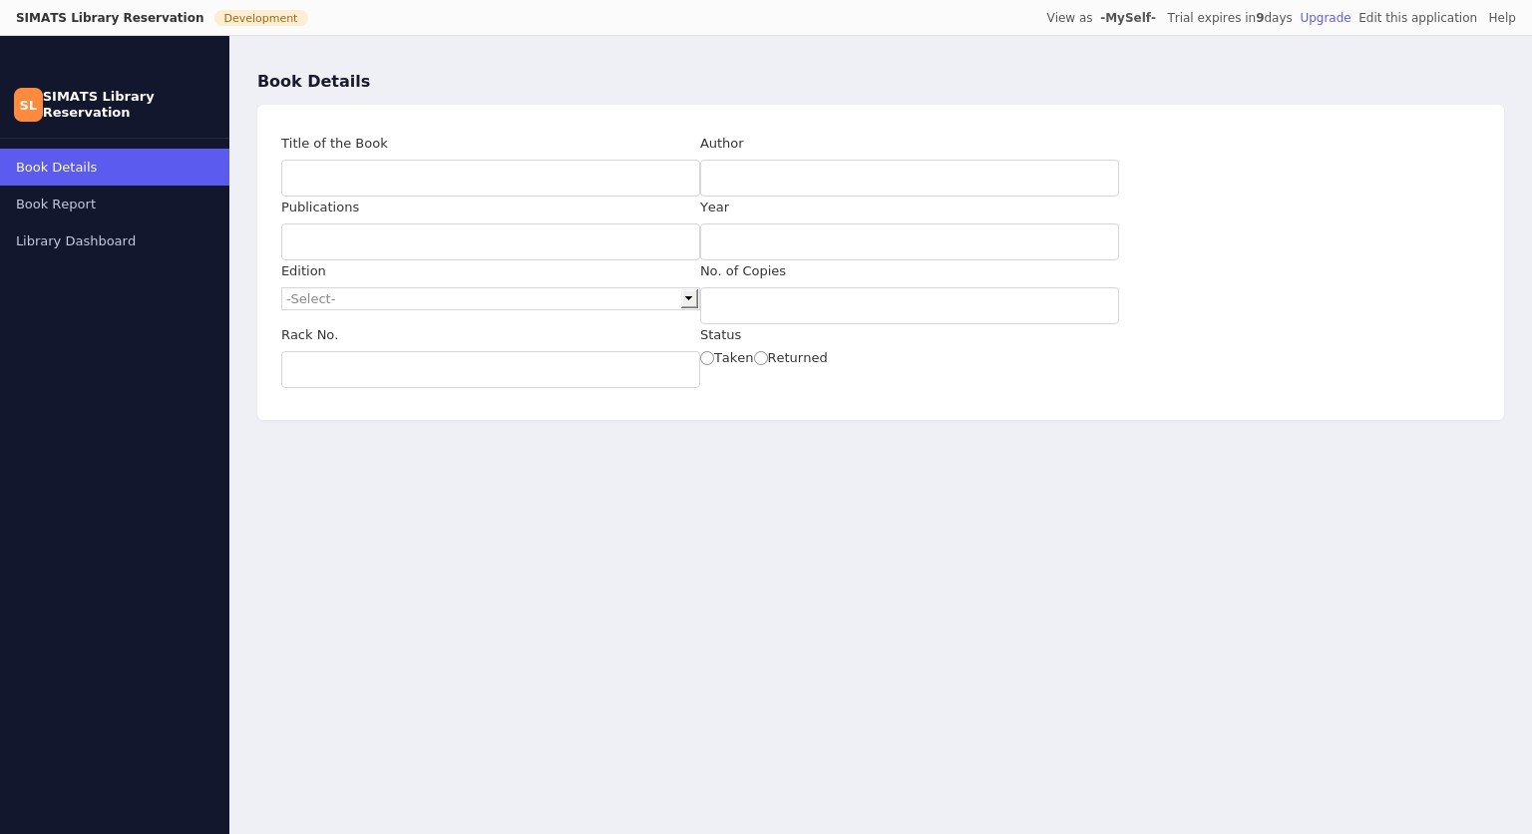
Book Details Form

Result
Thus the simple cloud software application for Library Book Reservation System (SIMATS Library) was created successfully using Zoho Creator to demonstrate the SaaS cloud model.

Ex. No: 5 Mark Sheet Processing System

Aim
To create a simple cloud software application for Mark Sheet Processing System using Zoho Creator to demonstrate the Software as a Service (SaaS) cloud model. The application includes fields such as Name of the Student, Register No., Subjects, Marks, Average, Percentage, Rank, and Overall Performance.

Output
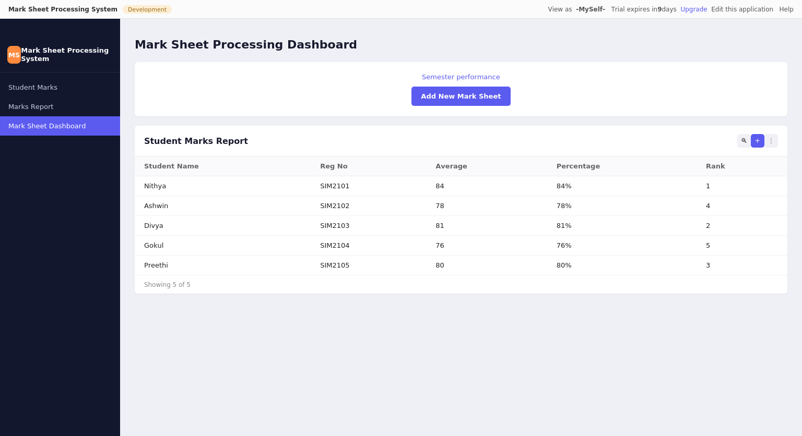
Mark Sheet Processing Dashboard
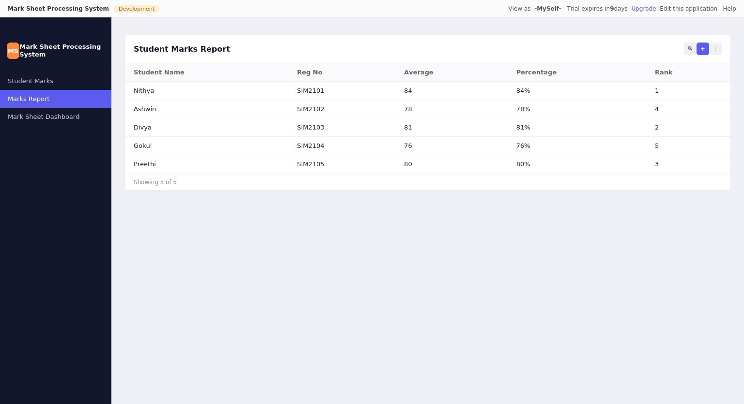
Student Marks Report

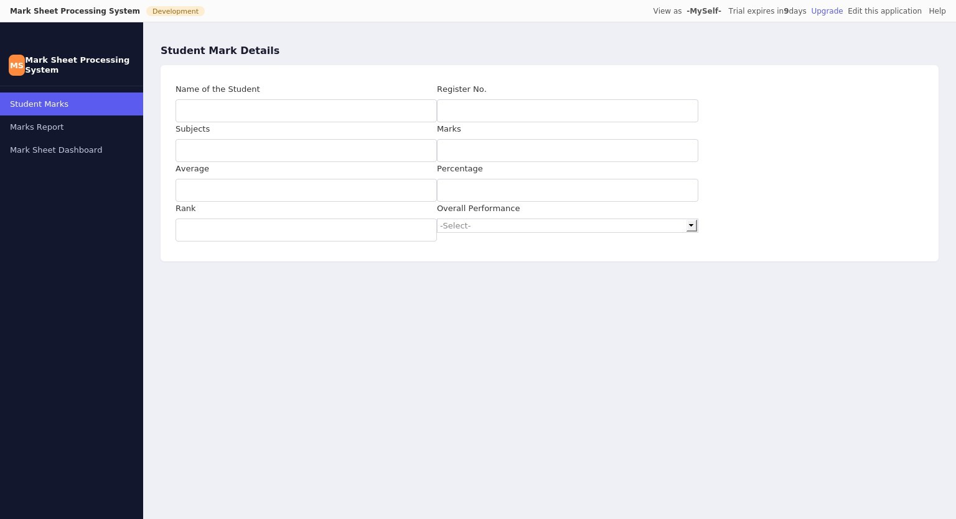
Student Mark Details Form

Result
Thus the simple cloud software application for Mark Sheet Processing System was created successfully using Zoho Creator to demonstrate the SaaS cloud model.

Ex. No: 6 Payroll Processing System

Aim
To create a simple cloud software application for Payroll Processing System using Zoho Creator to demonstrate the Software as a Service (SaaS) cloud model. The application includes fields such as Name of the Employee, Experience in Present Organization, Overall Experience, Basic Pay, HRA, DA, TA, Net Pay, and Gross Pay.

Output
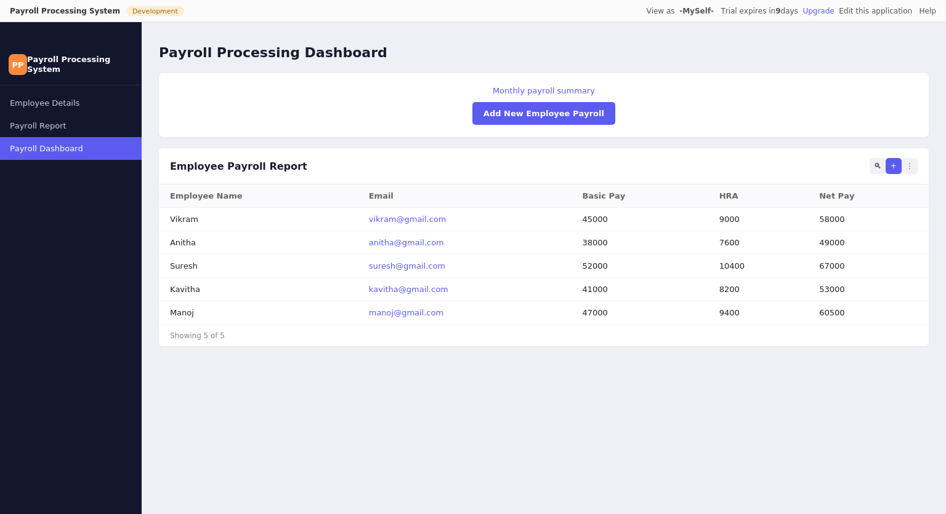
Payroll Processing Dashboard
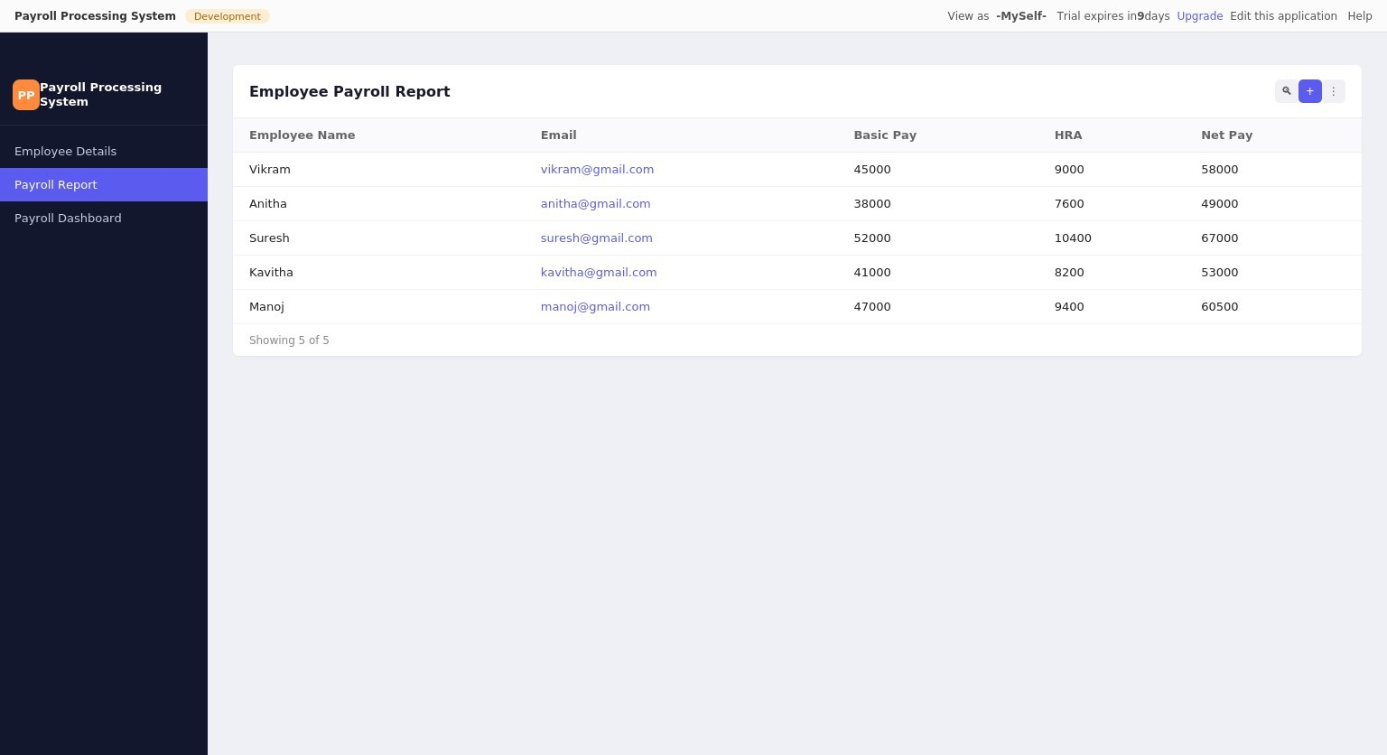
Employee Payroll Report

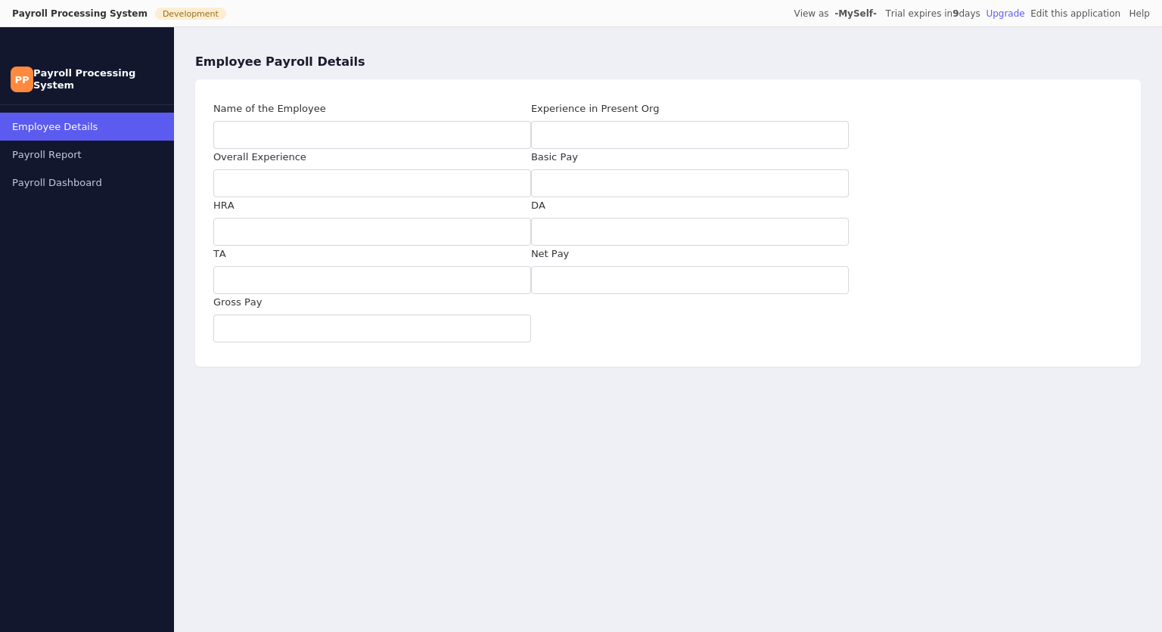
Employee Payroll Details Form

Result
Thus the simple cloud software application for Payroll Processing System was created successfully using Zoho Creator to demonstrate the SaaS cloud model.

Ex. No: 7 Students Attendance System

Aim
To create a simple cloud software application for Students Attendance System using Zoho Creator to demonstrate the Software as a Service (SaaS) cloud model. The application includes fields such as Name of the Student, Course, Present, Absent, Course Attendance, OD Request, Grade, and Attendance Percentage.

Output
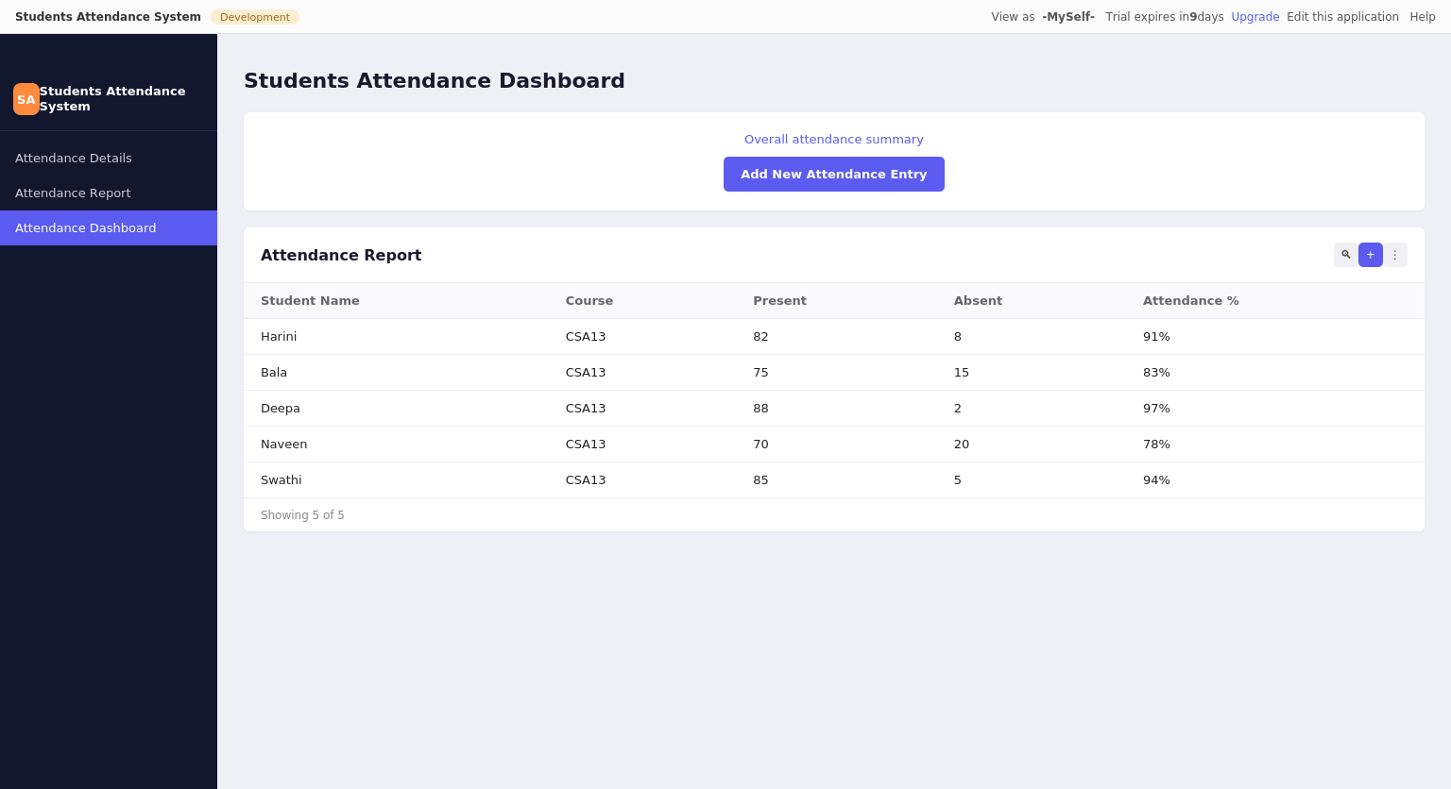
Students Attendance Dashboard
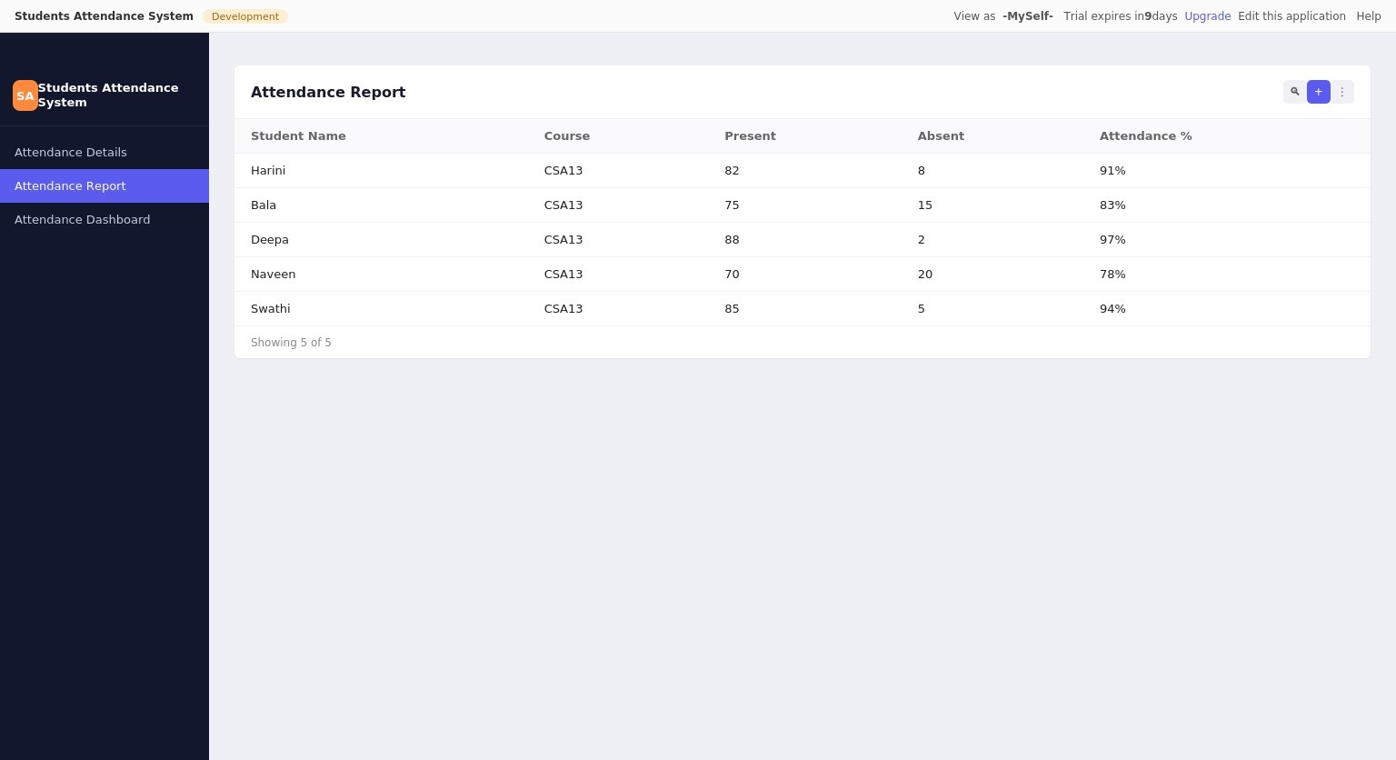
Attendance Report

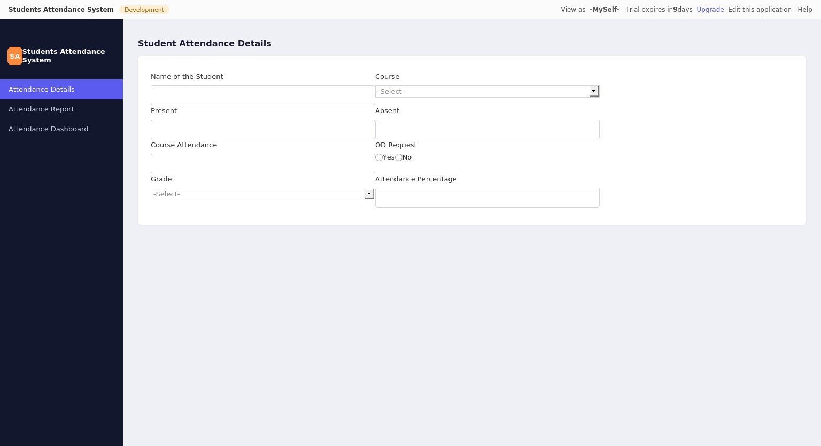
Student Attendance Details Form

Result
Thus the simple cloud software application for Students Attendance System was created successfully using Zoho Creator to demonstrate the SaaS cloud model.

Ex. No: 8 Student Counselling System

Aim
To create a simple cloud web application for Student Counselling System using Zoho Creator to demonstrate the Software as a Service (SaaS) cloud model. The application includes fields such as Student Name, Age, Address, Phone, Subjects Studied, Year of Passing, Percentage of Marks, and Domain Interest.

Output
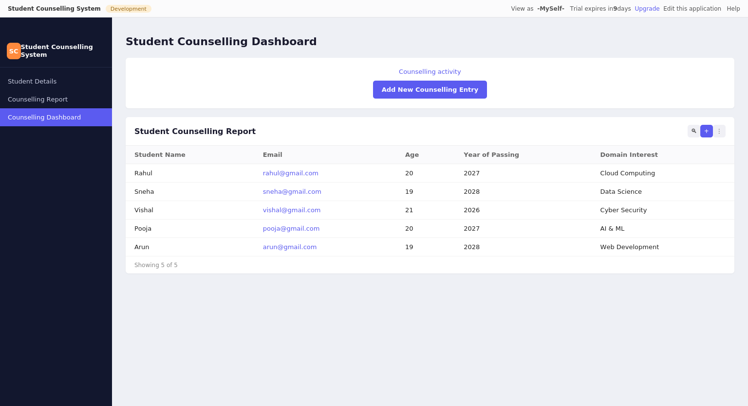
Student Counselling Dashboard
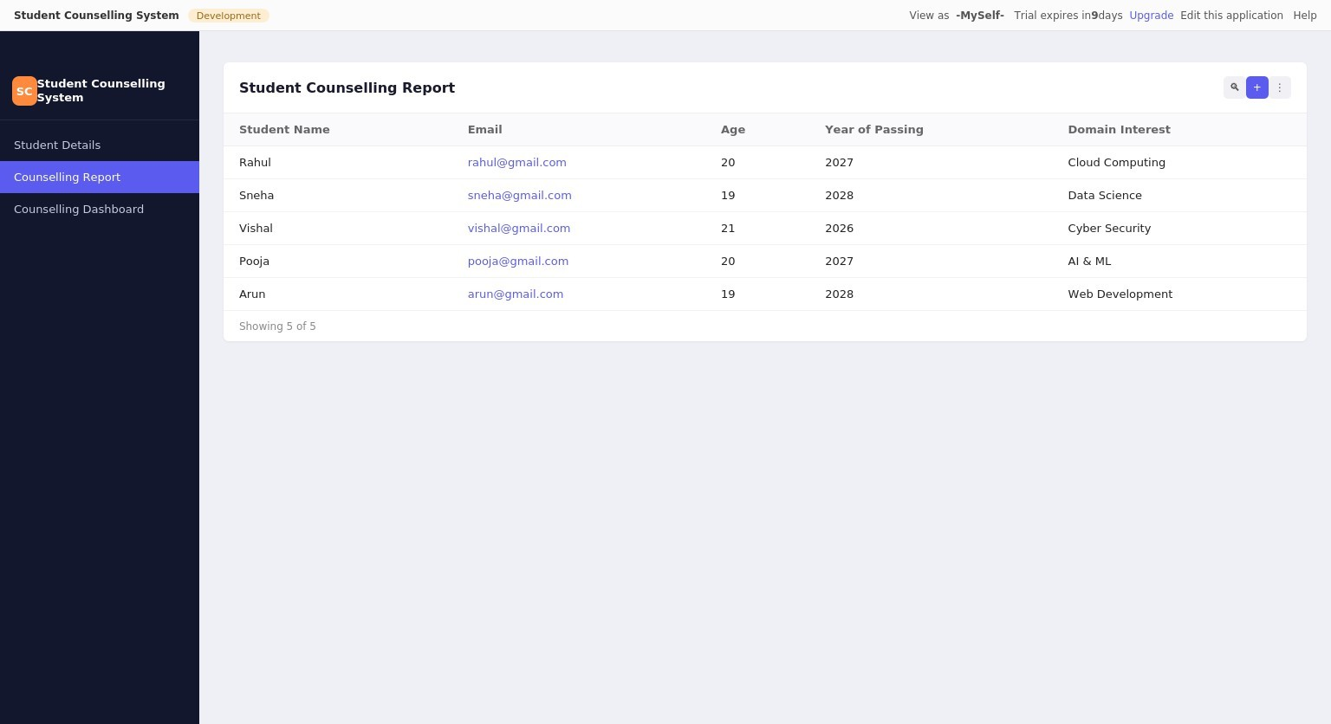
Student Counselling Report

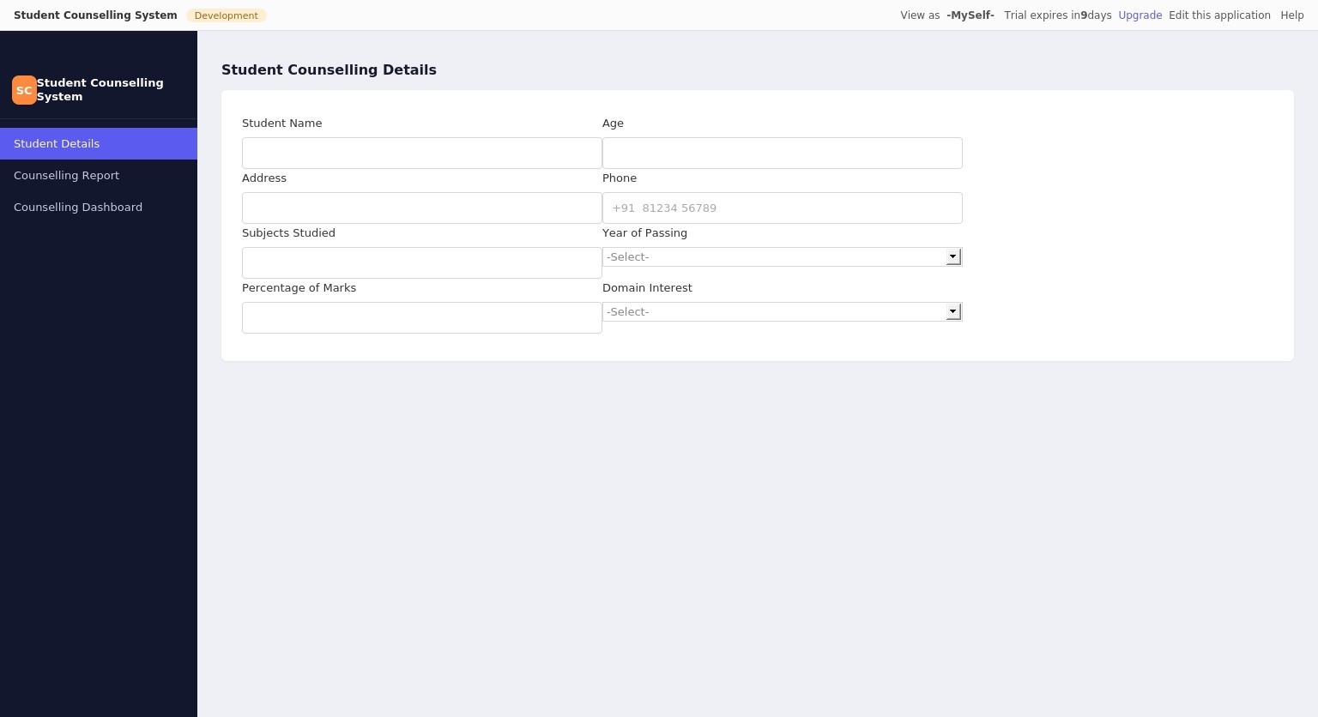
Student Counselling Details Form

Result
Thus the simple cloud software application for Student Counselling System was created successfully using Zoho Creator to demonstrate the SaaS cloud model.

Ex. No: 9 Hospital Information System (SIMATS Hospital)

Aim
To create a simple cloud software application for Hospital Information System for SIMATS Hospital using Zoho Creator to demonstrate the Software as a Service (SaaS) cloud model. The application includes fields such as Patient Name, Age, Address, Phone, Email, Attender Name, Attender Phone, Doctor Name, and Diseases.

Output
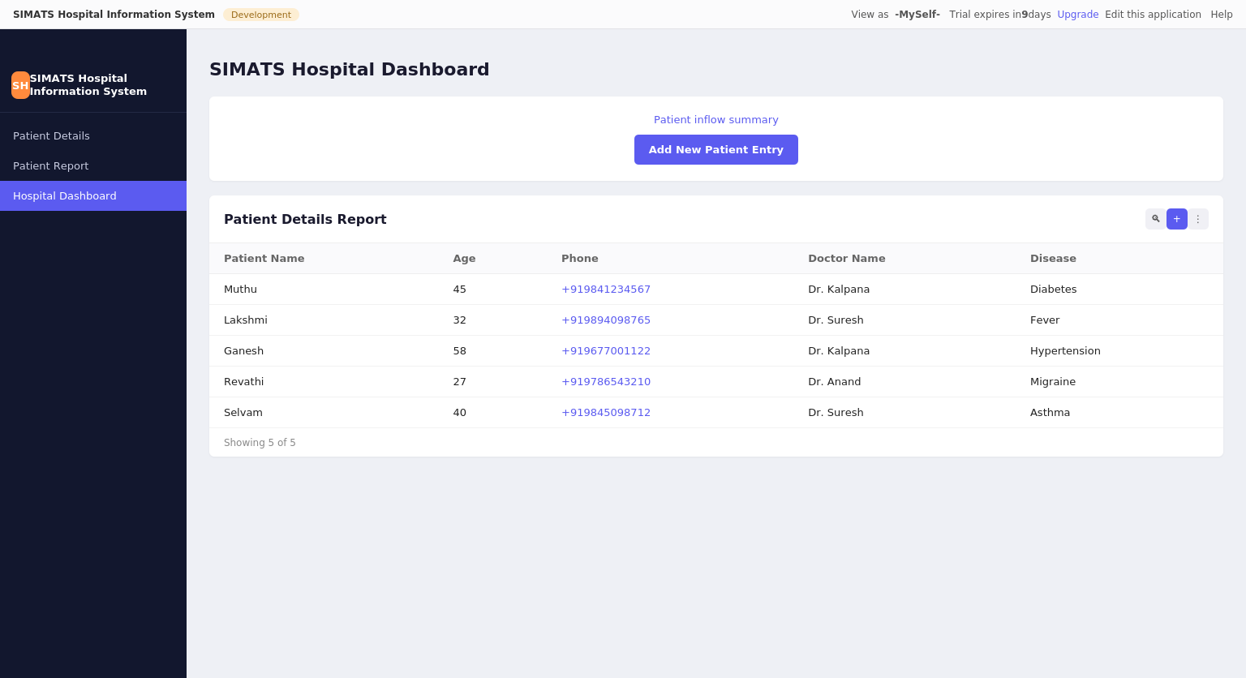
SIMATS Hospital Dashboard
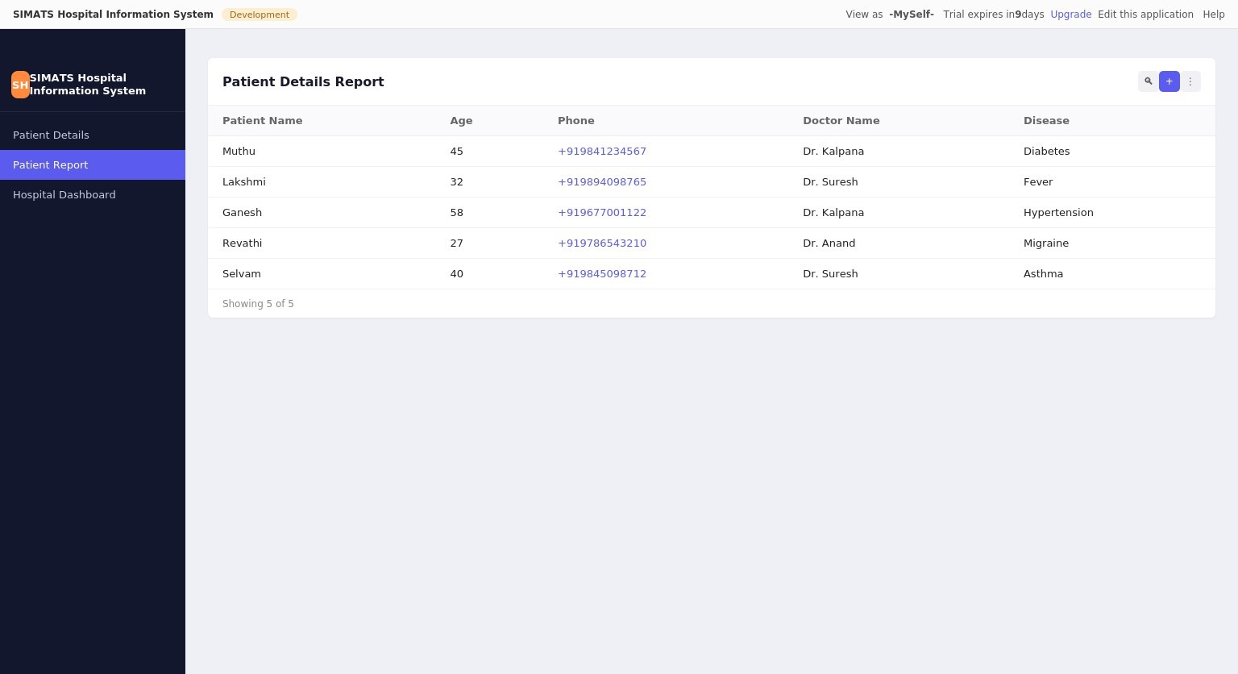
Patient Details Report

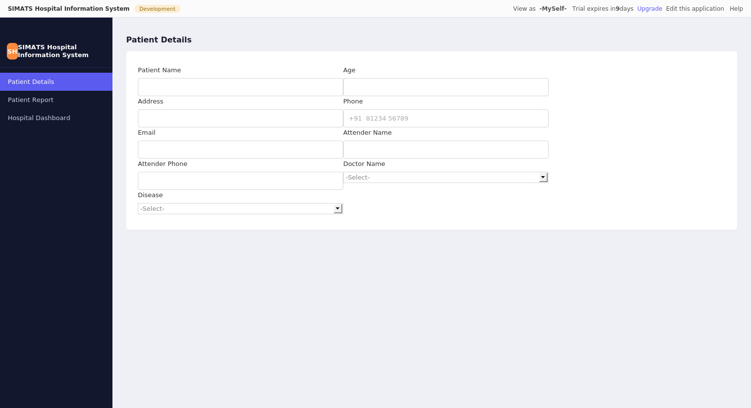
Patient Details Form

Result
Thus the simple cloud software application for Hospital Information System (SIMATS Hospital) was created successfully using Zoho Creator to demonstrate the SaaS cloud model.

Ex. No: 10 Student Information Display System (C Program)

Aim
To create a simple cloud software application to run a C program to display student information using Zoho Creator to demonstrate the Software as a Service (SaaS) cloud model. The application includes the template of Student Name, Register No., Address, Phone, Age, Courses, Grades and Attendance Report, Progress Report, and Semester Mark Sheet forms.

Output
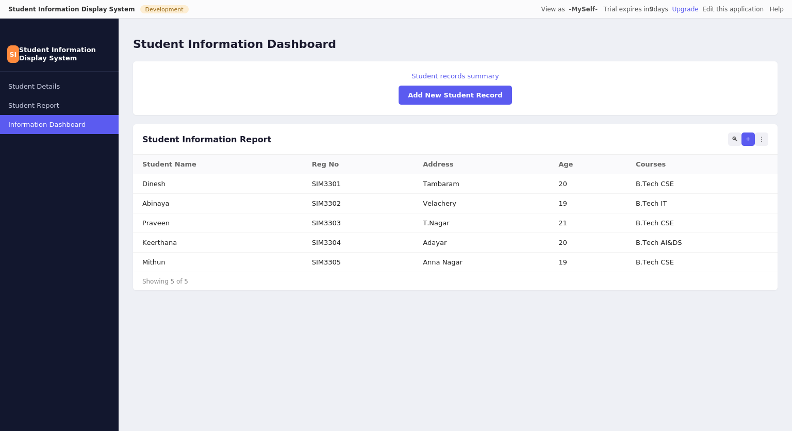
Student Information Dashboard
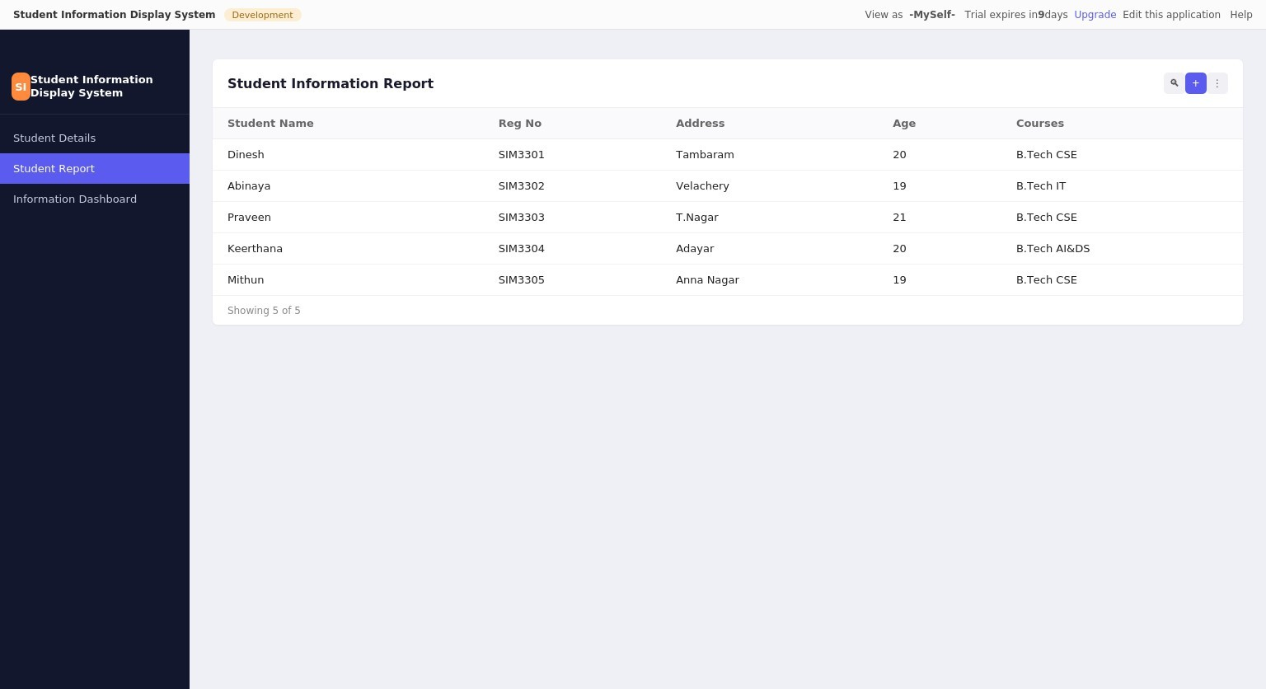
Student Information Report

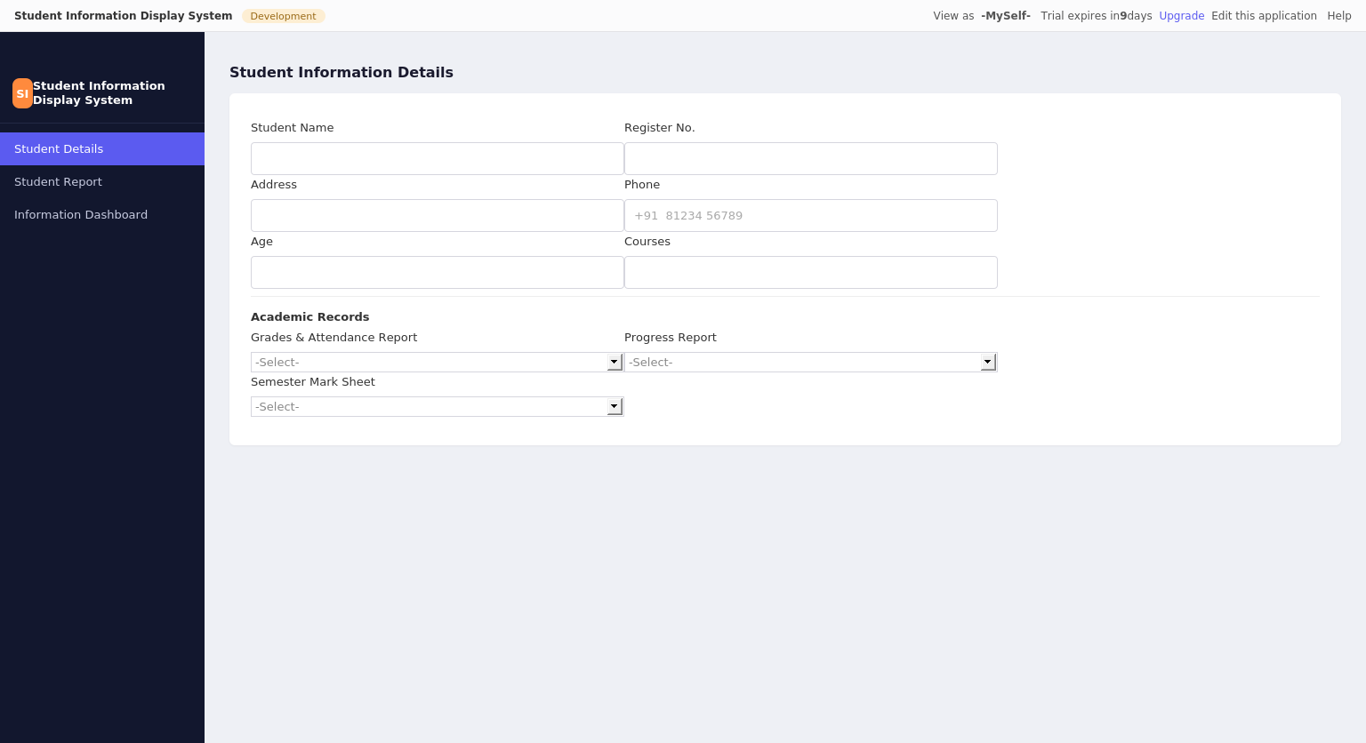
Student Information Details Form

Result
Thus the simple cloud software application for Student Information Display System (C Program) was created successfully using Zoho Creator to demonstrate the SaaS cloud model.

Ex. No: 11 Online Super Market System

Aim
To create a simple cloud software application for Online Super Market using Zoho Creator to demonstrate the Software as a Service (SaaS) cloud model. The application includes the template of Customer Name, Address, Phone, Email, Items, Quantity, along with the Item Classification form.

Output
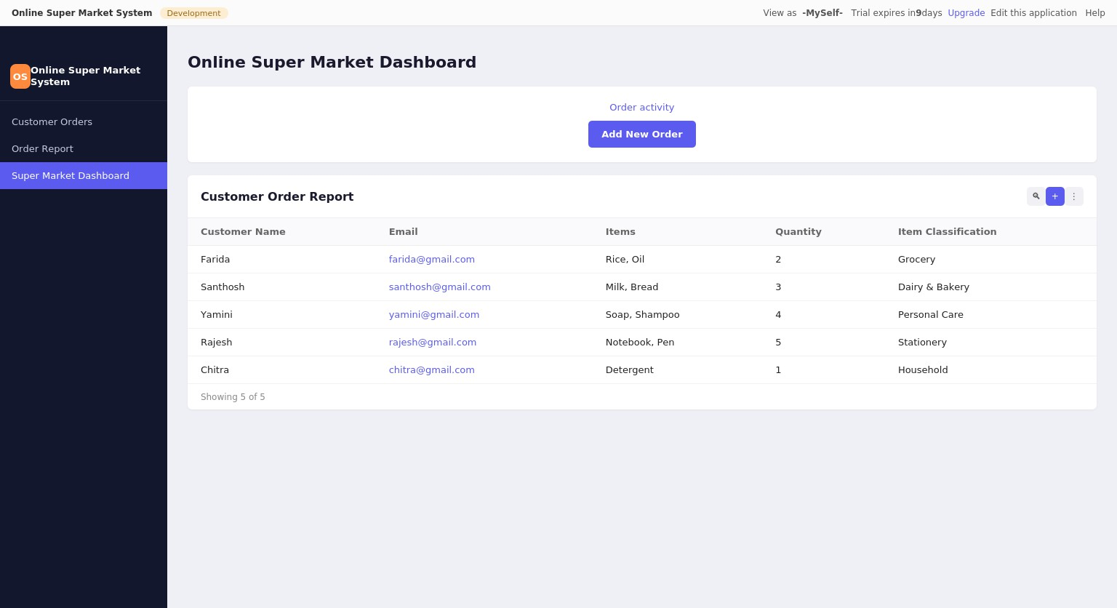
Online Super Market Dashboard
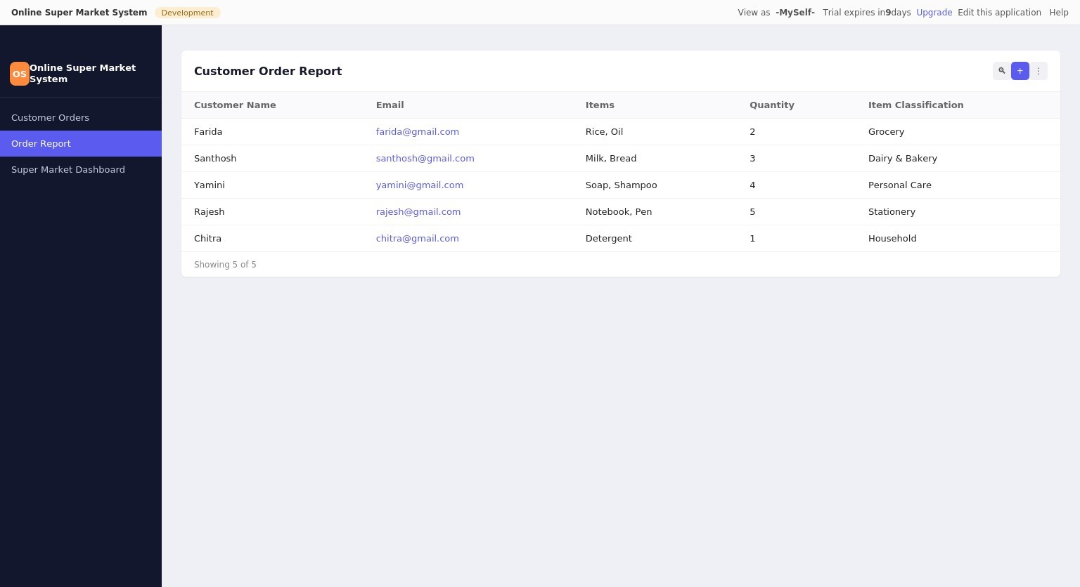
Customer Order Report

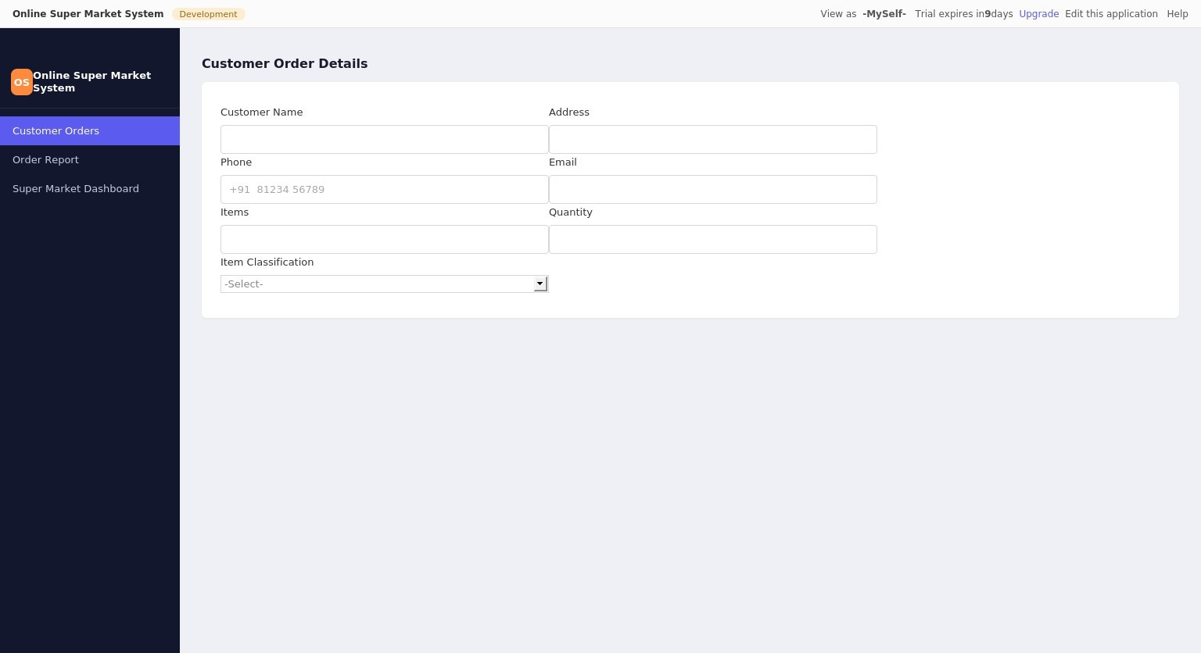
Customer Order Details Form

Result
Thus the simple cloud software application for Online Super Market System was created successfully using Zoho Creator to demonstrate the SaaS cloud model.

